Bachelor of Computer Applications

CS-76 Project

ANVESHAK-
A Character & Signature Recognition System

By
000445495 Vikrant Thakker

School of Computer and Information Science
Indira Gandhi National Open University
Maidan Garhi, New Delhi - 110068

ANVESHAK –

A Handwriting and
Signature Recognition
System

A word 'Impossible' itself says that 'I M Possible'

Contents

- FROM THE AUTHOR’S PEN.…………………………..............………….... 5
- ACKNOWLEDGEMENTS………......................……………………….……. 6
3. INTRODUCTION.............................………………………………………..… 7
  - GOAL OF MY WORK………….………………………………………..… 7
3.2 PURPOSE OF THIS DOCUMENT…..........................…………………….. 8
3.3 SCOPE OF PRODUCT........................................................………..… 9
3.4 DEFINITIONS, ACRONYMS, AND ABREVIATIONS….................…..…….. 9
3.5 REFRENCES......................................................…..........…………… 11
3.6 OVERVIEW.......................................…..........…............……………. 12
4. GENERAL DESCRIPTION.................................…....................... ………..12
4.1 PRODUCT PERSPECTIVE..............................…..................... ………..12
4.2 PRODUCT FUNCTIONS....................................……...…….... ………..12
4.2.1 Character Recognition......................................... ………..12
4.2.2 Signature Recognition..........................…..…...... ………..13
4.3 GENERAL CONSTRAINTS.........................................….…….. ………..13
4.3.1 Hardware Limitations...............................…......... ………..13
    - Criticality of Application......................….............. ………..13
- BASICS IN NUTSHELL………………………….…………………………….13
5.1 CHARACTER RECOGNITION BASICS……………………….…………….13
    - On-Line and Off-Line Recognition..……………... ……….14
5.2 HANDWRITING PROPERTIES…………………………………… ……….16
5.2.1 What makes a difference ?………………..……… ……….16
5.2.2 Character Properties………………………….…… ……….17
    - Graffiti Alphabet figure………………….…………. ……….18
6. SYSTEM ANALYSIS AND DESIGN (SAD).………………….……………...19
  - SYSTEM REQUIREMENTS…………………….…………………………..19
  - SYSTEM SPECIFICATIONS………….………………………….. ………..20
  - GENERAL SPECIFICATIONS……….…………………….………………..20
  - FEASIBILITY STUDY……….………………………….…………………..21
  - TECHNICAL FEASIBILITY……………………………………….. ………..22
- TOOLS/PLATFORMS, LANGUAGES USED…………………..…. ………..23
8. PROGRAM LOGIC………………………………………………….... ………..24
9. INPUT/OUTPUT OF THE PROJECT…………………..…………………….24
10. LIMITATIONS OF THE SYSTEM………………………..………..………….25
11. FUTURE EXPANSION………………..…………………..………..………….26
- SYSTEM DESIGN DESCRIPTION (SDD).……………..………..………….
  - INTRODUCTION…………..…………………….…………………………..28
    - Purpose………………………………….……………………28
    - Definitions and Acronyms………………..…………………28
  - DECOMPOSITION DESCRIPTION…………….…………………………..29
    - Module Decomposition….……………………………..……29
    - Data Decomposition…………………………………………30
  - DATA FLOW DIAGRAMS (DFDs)……………….…………………………..31
    - Character Recognition DFD..……………………………….31
    - Signature Recognition DFD………………………………...31
  - USER INTERFACE (Screenshots).………….…………………………..32
    - Main Screen………………………………………………….32
    - Character Recognition Screen……………………………..33
    - Signature Recognition Screen……………………………..34
    - Learning Session Screen…………………………………..35
    - About Screen…………………………………………..……36
13. CODING…………………………………………..………….…………………………..37

- From the Author’s Pen
Anveshak is an attempt to make the computer "intelligent" enough to be able to analyze and classify hand written characters and input patterns. It analyzes the input pattern in terms of its mouse movement information as well as the speed with which it was inputted.
This concept can be used in various fields like PDAs, security systems, training and many more and thus enhancing the process of human computer interaction (HCI). This project was undertaken as a semester project by 6th semester BCA student of IGNOU, India. I assertively hope that this effort will serve its purpose as a tool to enhance the existing systems involving HCI, handling security issues and training. I shall be obliged to receive your suggestions about the system at vikrant_thakker@yahoo.com
Regards,
Vikrant Thakker (000445495)

- Acknowledgements
I would like to convey my gratefulness to the entire Internet Community and personally to Mr. Philippe Crochat and Mr. Daniel Franklin of http://prochat.online.fr for their valuable response to my queries. Also my project guide Mr. Himanshu Kundaliya was the important source of inspiration and a store house of ideas. He continuously demanded rigorous introspection for self improvement. This was the most fruitful exercise as it rose the quality of the software to a great extent. The appreciation by my classmates enlivened the spirit of hard work in me, to improve the system to reach high standards. Finally, my regards to the IT Department of IGNOU and L.D. Arts College for providing me with the necessary infrastructure and encouragement through out the project.

The "Anveshak" Developer

- Introduction
3.1 Goal of my work
One of the ways to input text on the small devices will be to write characters on a small touch pad or directly on the screen. The goal of this project is to examine how this can be done and to implement an algorithm that performs single character recognition.
The reason why single characters are considered instead of whole words or sentences is that the touch-pad is so small that it gets too difficult to write the whole words. The task of recognizing single characters is also much simpler. It is true that when you get whole words instead of single characters you can use this extra information in combination with a dictionary to analyze the characters, but the problems that arise when you need to find baselines and segment the characters automatically are much more difficult so you loose what you gained earlier. The algorithm must be able to recognize numerals as well as upper and lowercase letters. The most common characters in the ASCII table must be supported. Recognition speed is equally almost important as the recognition rate (the ration of correctly specified characters) if the user should accept the method of writing on a tablet as a way to input characters. Recognition speed and Recognition rate are however two goals that cannot be totally fulfilled at the same time since a recognition system with high recognition rate with most algorithms also tend to be slow in execution.
  - Purpose of this document
This is a the Software Requirements Specification (SRS) for ‘Anveshak – Character and Handwriting Recognition System’. The purpose of this document is to give information about the end user’s requirements, both functional and non functional to the reader. This document provides :
- A description of an environment in which the application is expected to
operate.
- A description of the application’s capabilities.
- A specification of the application’s functional and nonfunctional requirements.
The software will be used by following people/groups :
- Initially the application designer will use the SRS. Designer will use the information here as the basis for creating the application’s design.
- Second, the client of the project, i.e. the concerned authority will review the document. The SRS will server to establish a basis for agreement between the client and developer about the functionality to be provided by the application.
- Third, the application maintainers will review the document to clarify their understanding of what the application does.
- Fourth, test planners will use this document to derive test plans and test cases.

3.3 Scope of Product
Anveshak will be working on a Windows Platform, allowing the users to input characters through the mouse, and also validating their signatures, against their sample signatures, based on time criteria.
The application will provide following capabilities :
- Currently the application will be accessed via a mouse, but in future, it may also be extended to support stylus based input.
- The users will be able to train the computer, their own way of writing
characters.
- Users will be able to train computer for recognizing their signature pattern.
- User will be able to get outcome on the screen, as well as via speakers.

3.4 Definitions, Acronyms, and abbreviation

ANVESHAK One who pursues. Seeker, searcher
SRS Software Requirement Specifications.
PC Personal Computer.

Adaptive learning An ability to learn how to do tasks based on the data given for training or initial experience.

Image Processing It can be widely defined as a technique to process the image to gather some sort of data from that. The data can be used further to take some action. The major part of this technique ranging from Image acquisition , preprocessing , segmentation and finally recognition or interpretation to give result.
Pattern Recognition An important field of computer science concerned with recognizing patterns, particularly visual and sound patterns. It is central to handwriting recognition , optical character recognition (OCR) and voice recognition. We can use this pattern for discriminate between the given set of distinguish inputs to get output.
Speech Synthesis It is a technique to use the Microsoft Text Voice engine to generate voice according to the text given . It can also generate the output voice according to the age as well sex. It is a fictitious term representing the TTS (Text to Speech) phenomenon.
TTS Engine It stand for Text – To – Speech Engine. It is nothing but a interface provided to the programmers from the proprietary software to use the TTS functions which are well according to the specification.

3.5 References
Links :
http://www.ccs.neu.edu/home/feneric/charrec.html
- This site is related to the fundamentals of OCR
http://www.geocities.com/SiliconValley/2548/ochre.html#source
- This site is related to the basics of Neural Networks, which is a concept widely used for AI Programming

Books :
Pattern Recognition and Image analysis
Earl Gose, Richard Johnounbaug, Steve Jost
-prentice hall India

Artificial Intelligence
Rich knight
Tata Mcgraw Hill

3.6 Overview
Anveshak is an attempt to make the computer "intelligent" enough to be able to analyze and classify hand written characters and input patterns. It analyzes the input pattern in terms of its mouse movement information as well as the speed with which it was inputted.

4. General Description
  - Product Perspective
Anveshak is used for the User authentication and data Input via mouse. The system is self-contained. However, it is possible to exchange data with other system through external interface if required.
4.2 Product Functions
The system can be functionally divided into subsystem :
- Character Recognition subsystem
- Signature Recognition subsystem
The functionality of both are given below

4.2.1 Character Recognition –

- Train the computer on the standard samples provided.
- Accept input as handwritten characters from the user.
- Map the pattern inputted to one of the standard patterns.
- Output the result in plain text as well as through an audio device.

4.2.2 Signature Recognition –

- For every new user collect sample of his/her signature.
- Store the inputted pattern in a way that preserves the information about the mouse movement as well as time based pattern and that cannot be deciphered.
- For an existing user accept signature in the same format as during training.
- Map the pattern inputted to the standard signature patterns.
- Authenticate the user if successful, else deny access.
- Output the result in plain text as well as through an audio device.

  - General Constraints

Hardware Limitations
The Anveshak is a PC based and there is a need for the arrangement of PC hardware.
    - Criticality of Application
Anveshak is designed to be used by end users with little computer background and hence would be designed in a user-friendly manner.
The system would be designed for easy to use, providing help instructions, and appropriate error messages for invalid user inputs.
5. BASICS IN NUTSHELL
5.1 Character Recognition Basics
In 1950’s electronic tablets that could capture coordinate data of pen-tip movements were invented. This created much activity in the field of on-line character recognition. This activity lasted through the 1960’s, ebbed in the 1970’s but was renewed in 1980’s. The growing market of hand-held computers has further increased the interest of this research area.
- On-line and Off-line recognition
On-line recognition means that the recognition is performed while the user writes. Data are captured using electronic tablets and the user is given direct feedback of the recognized characters. By contrast, off-line recognition is performed afterwards, i.e. on a grey-level bitmap obtained through scanning of a paper document. There is however no clear line between these two types when speaking of algorithms used. An on-line system could easily use algorithms meant for an off-line system by simply converting all the information to a bitmap, and of course loosing a lot of information such as acceleration, slope and information about where the stroke started and ended. There are also ways of extracting information from a bitmap image to produce guesses of how the strokes were drawn.
Both approaches have of course advantages and disadvantages.
- In on-line recognition you are given much more information to work with. You could get ordered sequences of points grouped into strokes by scanning from pen-down to pen-up, as compared to the unordered bitmap you obtain from a scanned document. You can get time stamp on all the sampled points , so that entities like pen-tip speed and acceleration can be calculated.
- Due to the fact that you have immediate contact with the user, the on-line recognition system could also have the ability to learn and adjust in real time to enhance recognition rate. The user could also show the recognition system how he likes to draw certain letters, to facilitate learning. An off-line system could of course also learn but it must do it without feedback from the user of what is correct or not.
- If your task is to produce a user independent recognition system then it could actually be overkill to use all information obtained from an on-line system. E.g. acceleration, pressure, and stroke order, since these entities tend to vary much between different persons and even between different samples of one person’s handwriting. This problem is easily fixed through by ignoring the unnecessary information. In a signature verification system, however, these pieces of information might be crucial to verify the signature.
- A big problem with on-line systems is that the user is required to use special equipment when inputting data. Writing with a plastic pen-tin on a hard slippery touch pad, is not the same as writing on a regular piece of paper. There could also be problems if the user has to wait for an on-line recognition system because the system is slow; the thought process would be interrupted.

  - Handwriting properties
5.2.1 What makes a difference?
The most important feature of an alphabet is that the differences between different characters are larger than the differences between different samples of a specific character produced by perhaps different writers. There are cases in our alphabet when one could argue that the alphabet was badly constructed from the beginning. The letters I and l (or the letter O and the number 0) are sometimes difficult to tell apart. You have to see them in the right context.
In single character recognition however, where you input one character at the time, you have no context, so you have to find other ways to separate characters of numerous meanings. There may be some information available if you look at the characters already written but since the user doesn't see these characters anymore, one cannot expect the user to remember and stick to for example a certain size of the characters. The Graffiti system used on 3Com's Palm Pilot uses two fields for input, one for letters and one for numerals. All letters written in the letter field will be lowercase unless you proceed the letter with a special shift symbol. All characters written in the numeral field will be interpreted as numerals (with some exceptions for math symbols like +, - and so on). The Jot system, developed by Communication Intelligence Corporation, has the input field divided in the middle by an imaginary line. Characters written on one side of the line will be recognized as lower case letters and on the other side you write numerals. Characters overlapping the two regions will be interpreted as upper case letters.
5.2.2 Character properties
The question of how you input your characters makes a strong impact on several factors including the input speed (the time it takes to write a character), the recognition speed (the time it takes for the system to analyze what you wrote) and the recognition rate (the rate of correctly classified characters) and a new user's learning speed. First there is the choice between multiple stroke characters or single stroke characters. Single stroke characters are easy from an implementor's point of view. There is no question when one character is finished and the next begins. You simply examine the pen-down and pen-up actions. This leads, however, to a somewhat strange looking alphabet since every character must be completed without lifting the pen. Both Graffiti use a kind of single stroke character set with some exceptions.
Characters with multiple strokes are easy from the user's point of view since he doesn't have to adjust to a new way of writing. There are however problems also with this. It takes often more time to input multiple stroke characters if you compare with a writer that has learnt the new one stroke characters. There is also no obvious way of knowing when the character is finished since you use the same area for every character. One may require that the writer makes a short pause between every character but that also makes it more slow.
    - Graffiti Alphabet figure

6. SYSTEM ANALYSIS AND DESIGN
6.1 System Requirements

As basic requirements of the system can be enlisted as :
- User interface for inputting a pattern.
- Pattern recognition algorithm.
- User interface for displaying the result in a pertinent manner.

The system can be functionally divided into subsystem :
- Character Recognition subsystem
- Signature Recognition subsystem

The functionality of both are given below

Character Recognition –

- Train the computer on the standard samples provided.
- Accept input as handwritten characters from the user.
- Map the pattern inputted to one of the standard patterns.
- Output the result in plain text as well as through an audio device.

Signature Recognition –

- For every new user collect sample of his/her signature.
- Store the inputted pattern in a way that preserves the information about the mouse movement as well as time based pattern and that cannot be deciphered.
- For an existing user accept signature in the same format as during training.
- Map the pattern inputted to the standard signature patterns.
- Authenticate the user if successful, else deny access.
- Output the result in plain text as well as through an audio device.
  - System Specifications
Character Recognition –

- If the system is trained for a particular user, it gives more than 90% accuracy for that user.
- For generic cases the accuracy is about 70%.
- The training practically takes 2-3 minutes on an Intel Pentium III

Signature Recognition –

- The accuracy of the system varies between 50-70% and is highly susceptible to the training pattern it receives.
- The training practically takes 2-3 minutes.
These values have been found empirically and are contingent because they depend on the nature of the process and the design of the system.

  - General Specifications

1. The system is implemented using Visual Basic 6.0.
2. Right now the system has been tailored to work on the Windows platform using Microsoft SQL as a database.
3. For the audio enable output the machine should also have Microsoft Voice Text installed.
6.4 Feasibility Study

Operational Feasibility

Anveshak is designed to be used by end users with little computer background. So, its basic operation is kept as simple as possible. Online help with each screen makes it possible for a new user to use Anveshak more easily. The study for the two major subparts of the system is given below.
- Character Recognition

The character recognition part of the system makes it possible for any user to input characters with almost 70% to 90% accuracy. Hence, when used as a method of input with PDA devices, the system improves efficiency to a great extent. It gives a totally new way of inputting which is currently not there in any PDA. Right now the system accepts input by the means of Mouse movement. The rate of error which is currently about 30% for generic user can be reduced to 10% if the system is trained for a particular user.
- Signature Recognition

This subsystem can be used as a generic authentication system in place of common password based authentication systems. Every user's signature is unique which can be described by its graphical pattern and time pattern (speed). The time based pattern recognition reduces the chances of intrusion. Users can have problems in signing with mouse but with use of stylus, the system shows greater usability.
6.5 Technical Study

Anveshak is a tool to enhance the systems having human interaction in terms of handwritten characters or as a security system. Hence the given utilities are required to be implemented by the system.

- A GUI and method for graphical input

For the system we need a tool which has graphical elements for input, using which we can grab the input given by mouse. Visual Basic is a technology having such facility, and with it’s components, it is very easy to create and maintain GUI.

- Algorithm for recognition of character / signature

To determine the correct character out of all the possible answers a pattern recognition algorithm is needed. Here we have implemented an algorithm that looks at the mouse movement and calculates the slope difference instead of looking at the pixels for recognizing the characters. The mouse movement algorithm is many times faster as compared to the pixel algorithm, and also it is the simplest and most elegant way of doing it.
- A method for audio output

As Anveshak gives output in visual as well as audio form, it uses Text To Speech (TTS) technology for the same. The Microsoft Voice Text is used for this module.
7. TOOLS/PLATFORMS, LANGUAGES USED

Currently the system would be tailored to work only on a Windows Platform with MS SQL as database.

Since Visual Basic with its ready to use GUI components is one of the most popular programming language for Rapid Application Development, all the coding will be done using the Microsoft’s product Visual Basic 6.0 as a front-end and MS SQL for storing the data as Back-end. Point to remember is that this is not a database application and the main purpose of this program is only to implement the logic of character recognition and hence the database selected is MS SQL that is easy to use with Visual Basic.
- This might change in the future, by writing the code using the platform independent language Java. However the use of Java poses certain restrictions on the algorithm. This is due to the fact that Java programs are interpreted and therefore not as fast as a program for example written in C or VB, and since recognition speed is important this is clearly a problem.
- For the audio enable output the machine should also have Microsoft Voice Text installed.

8. PROGRAM LOGIC
This program uses the database file Data.mdf . Each letter would have 100 movements made of 2 digits. When the form loads these numbers would be put in an Alphabet array. When you draw a letter the program compares your movement to each letter’s movements. The letter with the highest match is the letter. The movement is compared using the Direction function. I give it the mouse position and the previous mouse position and then it gives me a number indicating the direction. By adding more possible directions the program becomes more accurate.
The Logic for Character and Signature recognition remains the same as above,
A timer would be set specifically for the signature recognition that keeps the track of time taken to draw a particular signature. This would make the life harder for invalid users trying to break into the systems by simply copying the signature.
9. INPUT/OUTPUT OF THE PROJECT

INPUT
The system is divided into two sub parts : 1) Character Recognition and
2) Signature Recognition
- Character Recognition - Accept input as handwritten characters from the user.
- Signature Recognition - Accept Signature patterns of user.

OUTPUT
- Character Recognition - Recognize the character and display it in plain text as well as through an audio device.
- Signature Recognition - Validate the User based on his Signature pattern and display an appropriate message.
10. LIMITATIONS OF THE SYSTEM

Currently the system would be tailored to work only on a Windows Platform with MS SQL as database.

Since Visual Basic with its ready to use GUI components is one of the most popular programming language for Rapid Application Development, all the coding will be done using the Microsoft’s product Visual Basic 6.0 as a front-end and MS SQL for storing the data as Back-end. Point to remember is that this is not a database application and the main purpose of this program is only to implement the logic of character recognition and hence the database selected is MS SQL that is easy to use with Visual Basic.
- This might change in the future, by writing the code using the platform independent language Java. However the use of Java poses certain restrictions on the algorithm. This is due to the fact that Java programs are interpreted and therefore not as fast as a program for example written in C or VB, and since recognition speed is important this is clearly a problem.
- For the audio enable output the machine should also have Microsoft Voice Text installed.

- FUTURE EXPANSION

- To port Anveshak on PDAs like PalmPilot :
Anveshak can be ported on small Palm-sized PDAs to be used as a character recognition tool. We can use it to recognize the data and send it to different modules of underlying OS. Here it will be great improvement compare to the existing Vector based technology where the user has to stick to some sort of predefined conventions to write characters. We can safely port the Anveshak on PDAs to improve the user flexibility to write the characters at his/her ease.

- Recognition of generic character set that can be used for applications like OCR
Anveshak can be used to distinguish between a generic set of characters to discriminate a perfect one. In application like OCR which involves reading text from paper and translating the images into a form that the computer can manipulate (for example, into ASCII codes) we can use the existing Anveshak’s pattern recognition capabilities to recognize characters after they are being extracted from an image. I am in a plan to extend Anveshak ‘s capabilities to recognize hand-written characters also.

- Making the authentication system robust by embedding more constraints
It can also be used as a strong Authentication system as a whole or as a small Authentication module in an existing system to make it more robust. Since Anveshak is able to recognize signatures with constraints of speed of signature as well as its pattern we can use it to measure confidentiality level of the person who signs it. We can use Anveshak by embedding its logic into a small smart-card based authentication system, where we can authenticate users using their hand-written signature on the card itself, So then having his sign on the card can only be valid to enter in the system environment.

- Stylus integration for more perfect input.
Stylus are pen based device generally used for signing on a paper like pad to feed the data into the computer system. We can use Anveshak to co-operate with the stylus mechanism to enter signature, directly to Anveshak environment. Since the flexibility at user side will be improved in this case, The authentication per user basis will become more easier.

- System Design Specification (SDD)
12.1 Introduction
This is the Software Design Description (SDD) for Anveshak- Character and Signature Recognition System.
The purpose of this part of document is to give functional information to the reader.
This document provides :
- A description of the application’s capabilities.
- Description of relationship, dataflow, user interface, etc.
12.1.1 Purpose
Describing the details of the proposed software Anveshak, with modules, entities, and processes.

12.1.2 Definitions and Acronyms
SRS Software Requirements Specifications
SDD Software Design Description

12.2 Decomposition Description
Using Entity Relationship Diagram and Data flow diagram shown in Appendix these decompositions are made.

12.2.1 Module Decomposition

Anveshak – Character & Signature Recognition System
Anveshak – Character & Signature Recognition

Learning Session Module
Character Recognition Module
Signature Recognition Module

Teach new Characters & Recognize the drawn character. Validate Signature.
Signatures. Add details to Info from MastChar Info from MastChar
MastChar

12.2.2 Data Decomposition

Tbl_Mast_Data

Tbl_Mast_Data

Field Name | Data Type | Description | Field Size
Name | Text | Stores the UserName of the person who inputs the character. | 30
Char | Text | Stores the alphabet that has been taught. | 50
String | Text | Stores the mouse movement information of the taught alphabet. | 210
Time | Int | Stores the time taken to draw a alphabet while teaching to computer. | Long

12.3 Data Flow Diagrams (DFD)

12.3.1 Character Recognition DFD

Draw character
As Input

User

Data in
mousemovement
form result in
calculate slopes audio
form
Synthesizer
Speak Plain Text

Show Result

Fragment data

Result Result

12.3.2 Signature Recognition DFD

Draw Signature
As Input
User
Synthesizer
Speak Plain Text

Validate Signature

Fragment data

Data in
Mouse Movement
Form result in
audio
Calculate slopes form

Result Result
  - User Interface (Screenshots)

    - Main Screen Snap

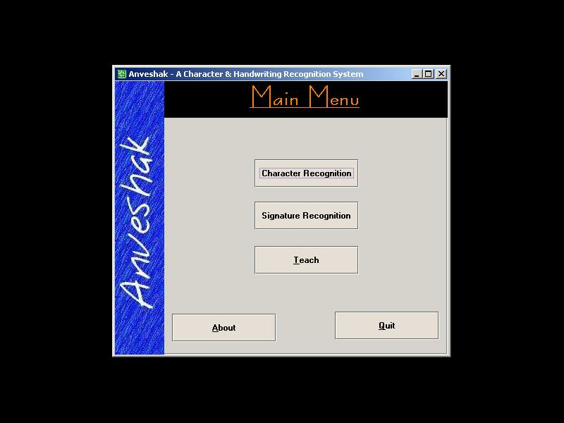

    - Learning Session Screen

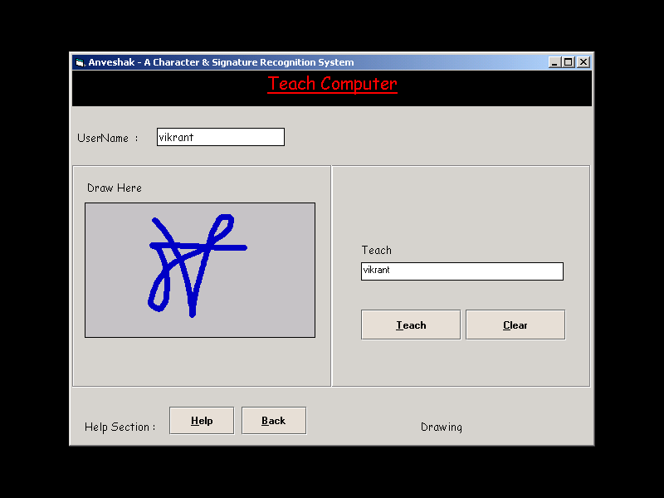

    - Signature Recognition Screen

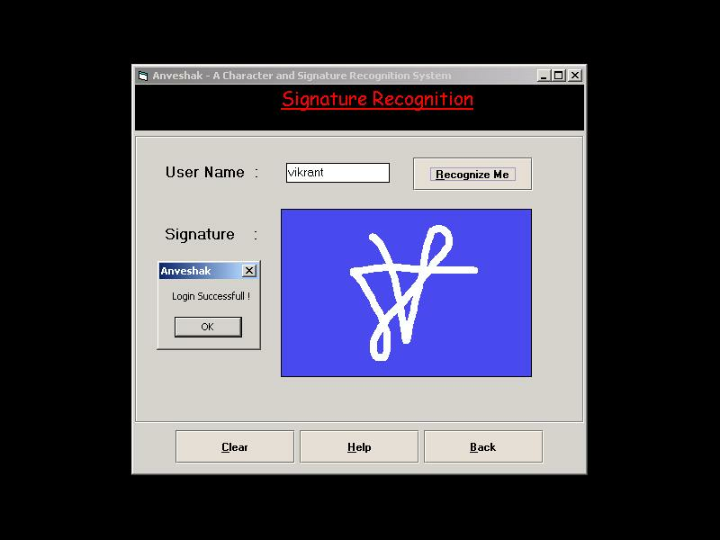

12.4.4 Character Recognition Screen

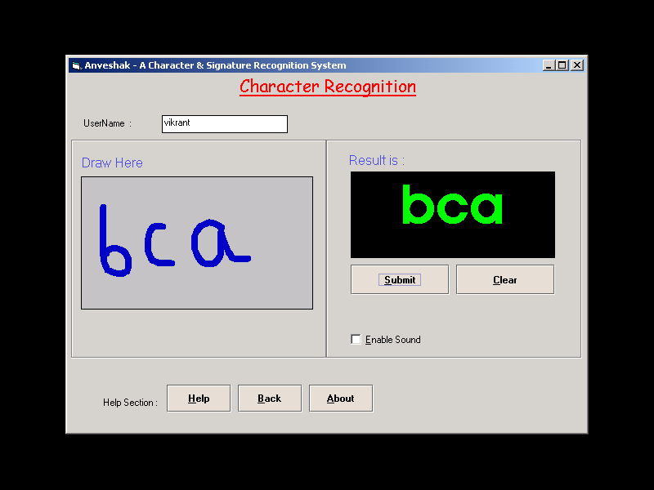

12.4.5 About Screen

